Home Page

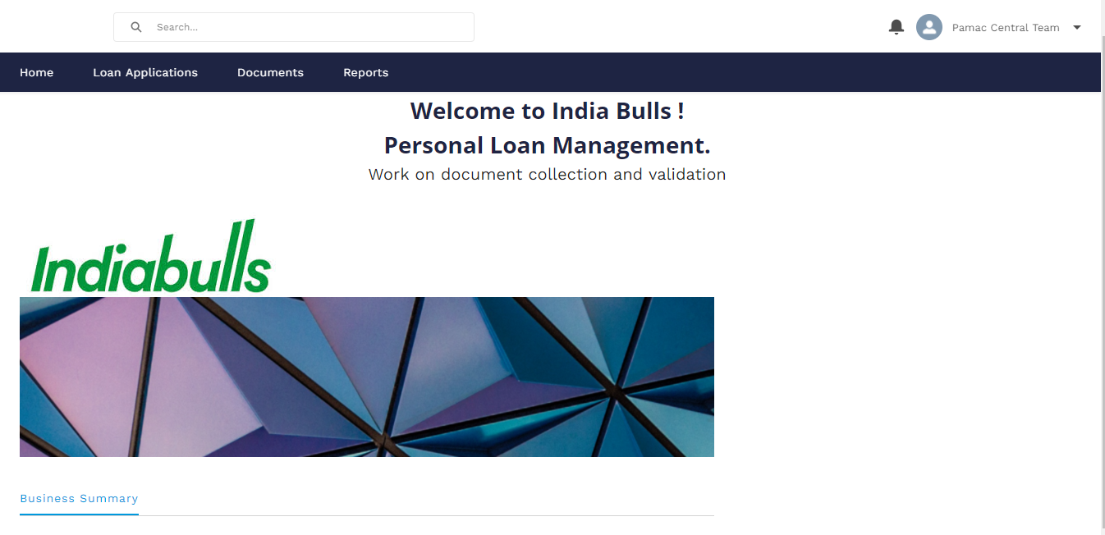

Click on Loan Applications to view the document list

From the list view the Image CAM preparer select the list of leads where CAM preparation is pending 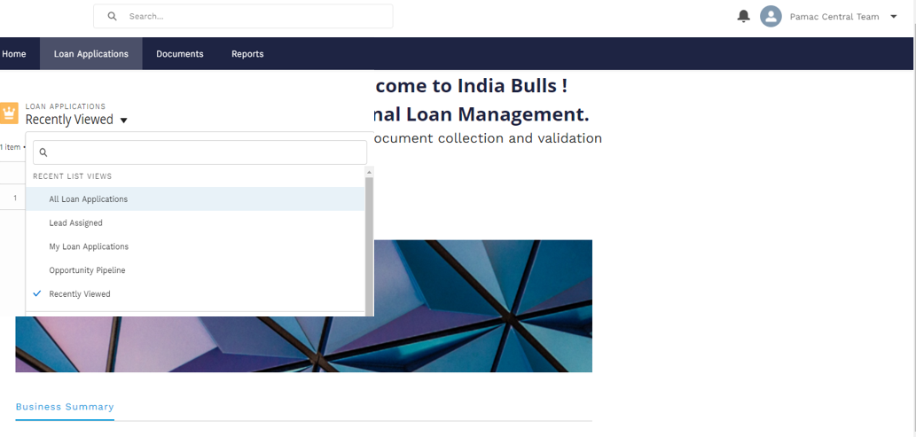

Lead level view – click on generate CAM report to create the CAM

Lead level view - Click on related to view documents uploaded against this lead

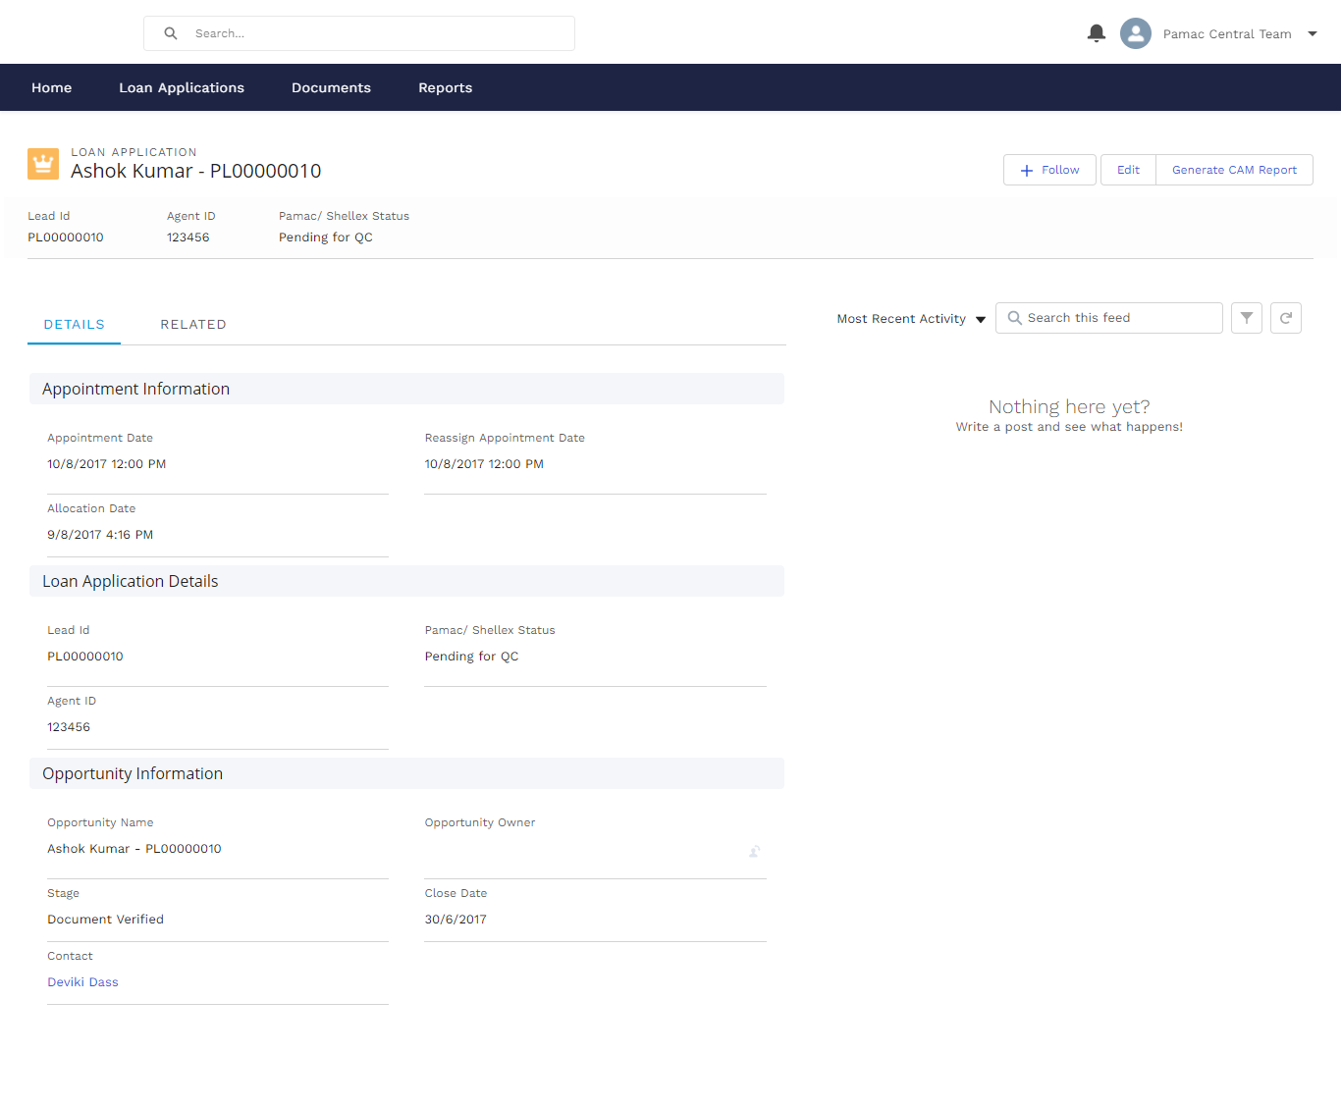

CAM Form

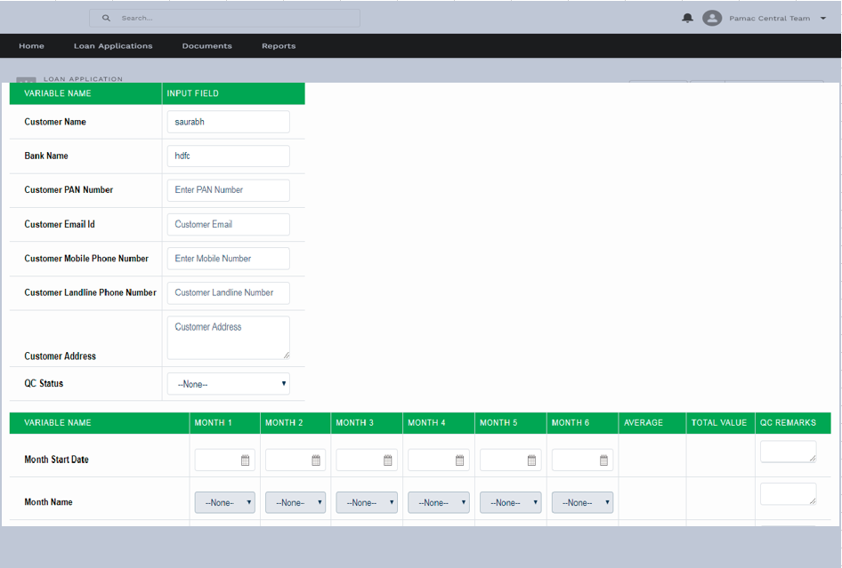

Click on Related tab view

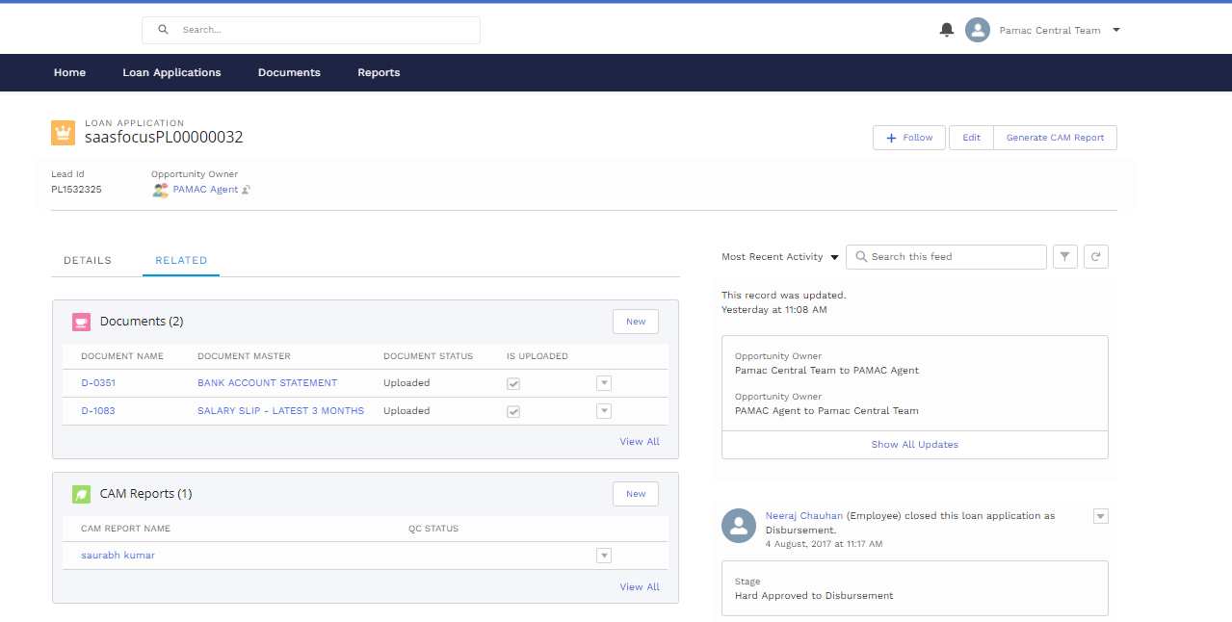

CAM preparer will click on the document name to view the images uploaded against it

Image view list inside document

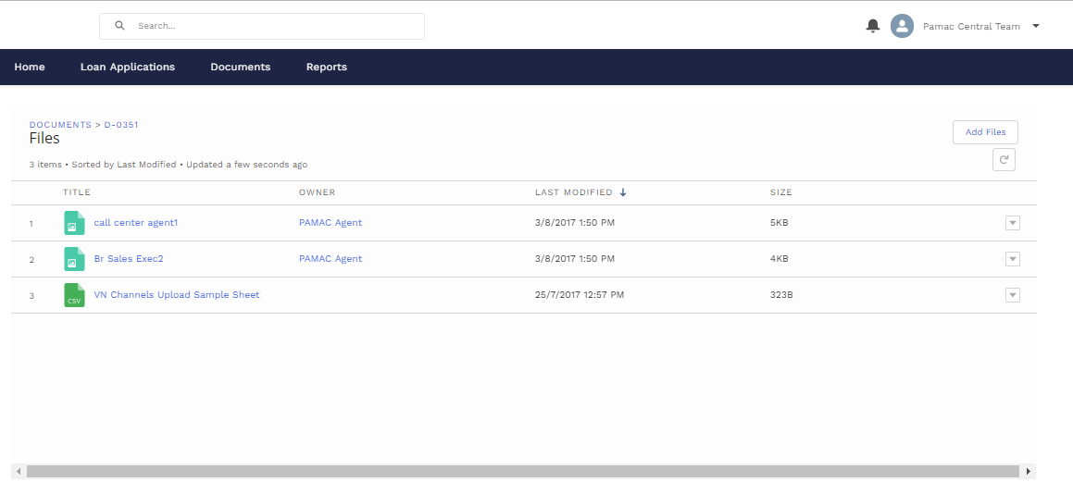

From the lead level view, the CAM preparer will click on edit to update the document status, and from the PAMAC/Shellex status drop down update the status as CAM QC completed

